**Lecture: Task Order - Pre and Post Tasks**

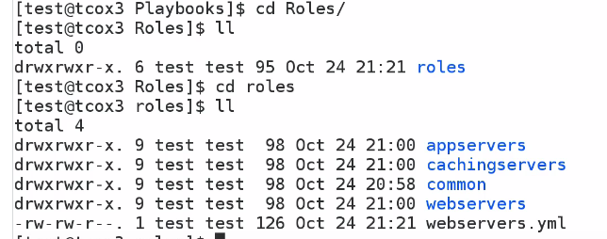

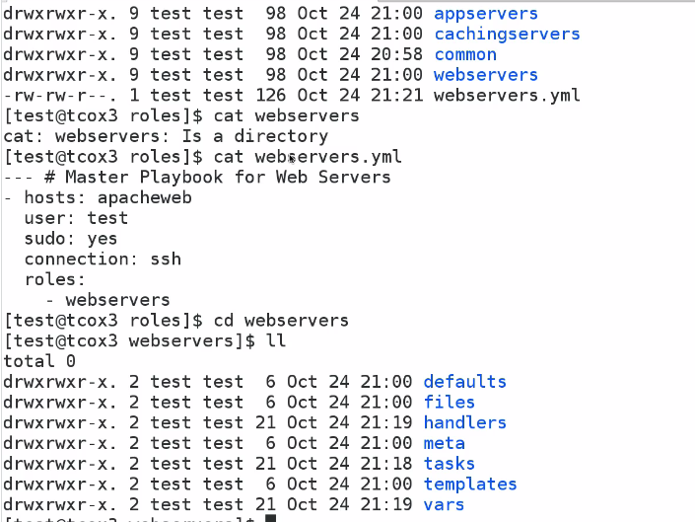

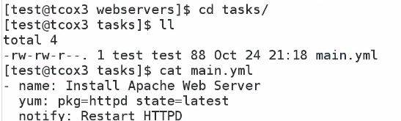

In role task always gonna run first

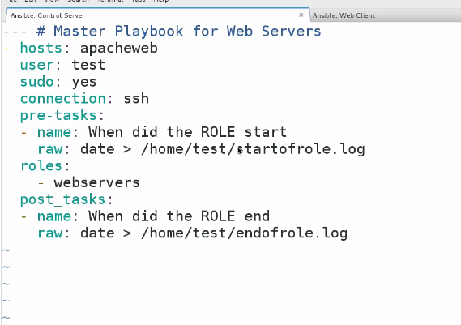

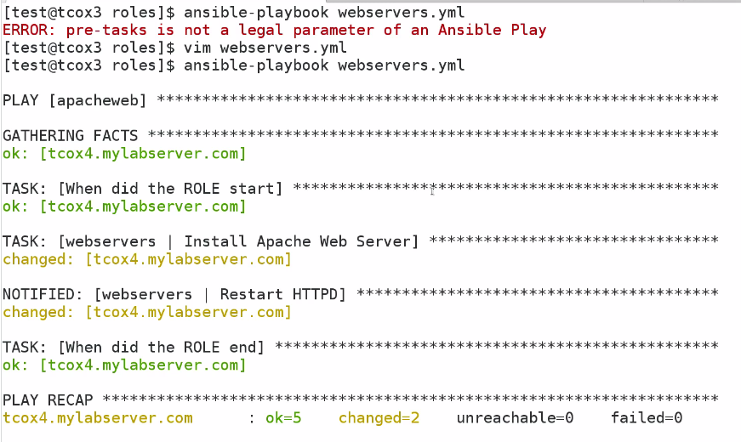

So there is little mistake it should be pre_tasks

And we can add pre task before role as well as post

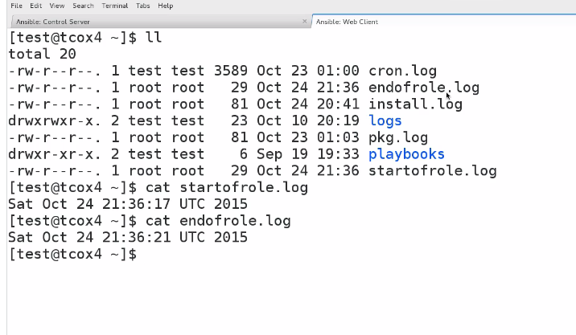

WE CAN DO THING LIKE RUN BEFORE THE ROLE ,AND AFTER THE ROLE